Experiment:5
Aim:
To write a Python program to solve the Missionaries and Cannibals problem using Breadth-First Search (BFS).
Algorithm:
  - Start with 3 missionaries and 3 cannibals on the left bank.
  - Place the boat on the left bank.
  - Use a queue to perform Breadth-First Search (BFS).
  - Generate possible boat movements: one or two missionaries, one or two cannibals, or one missionary and one cannibal.
  - Check that the number of people on each bank is valid.
  - Ensure cannibals never outnumber missionaries on either bank when missionaries are present.
  - Add each valid, unvisited state to the queue.
  - Repeat until all missionaries and cannibals reach the right bank.
  - Print the solution path.
Code:
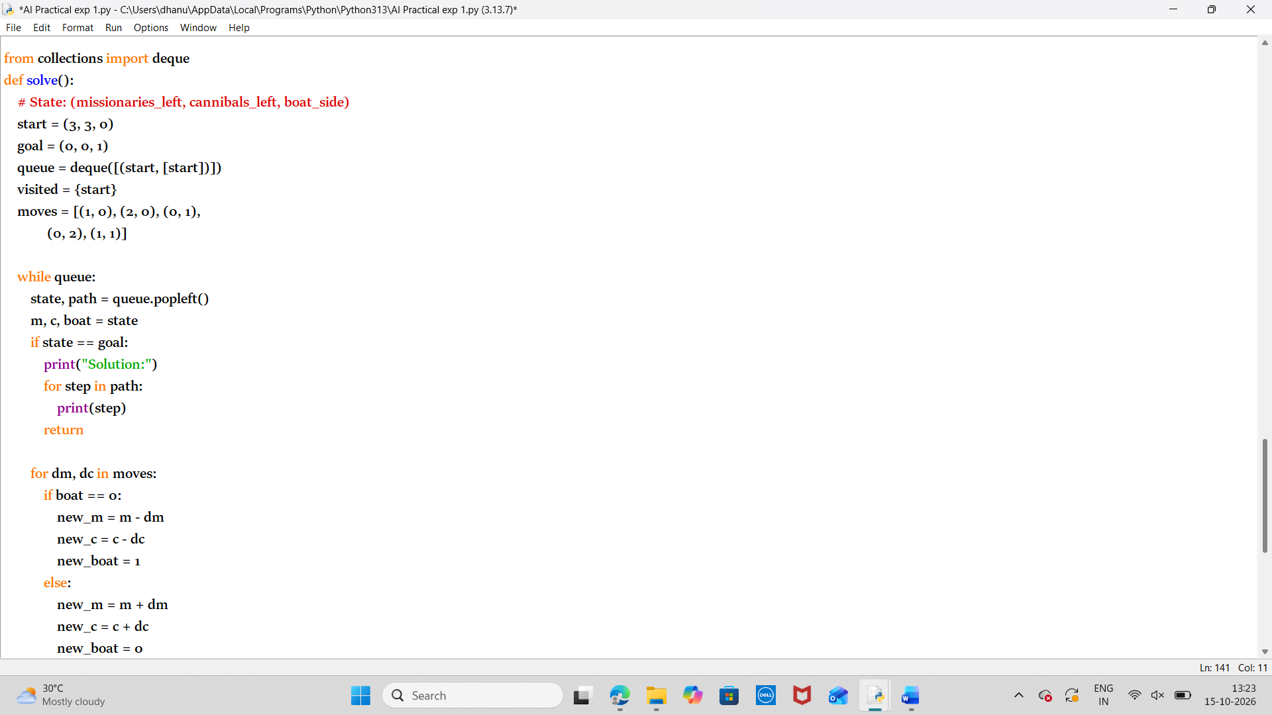
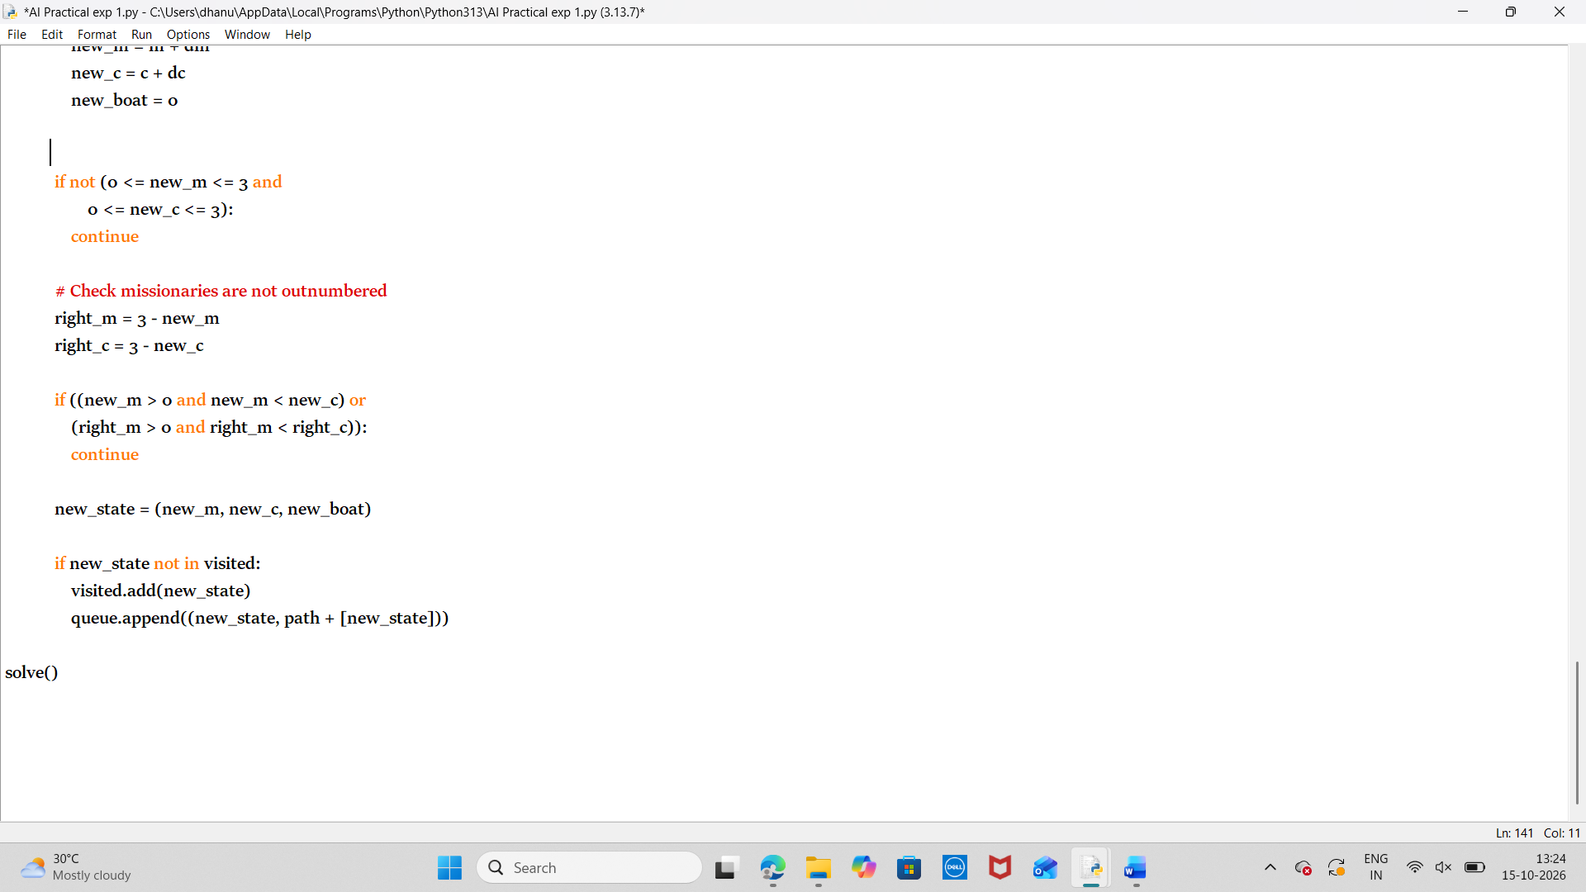
Output:
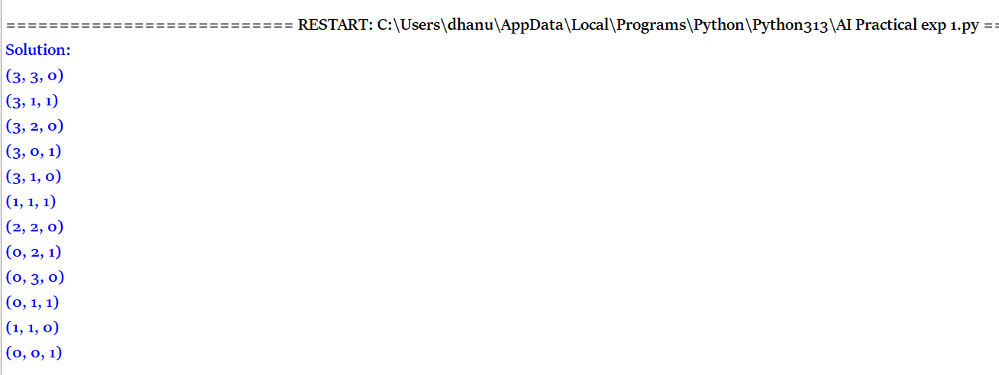
Result:
Thus the python program to solve the Missionaries and Cannibals problem using Breadth-First Search (BFS) has been executed successfully

